**OSM Data Wrangling With SQL:**

**A Victoria case study**

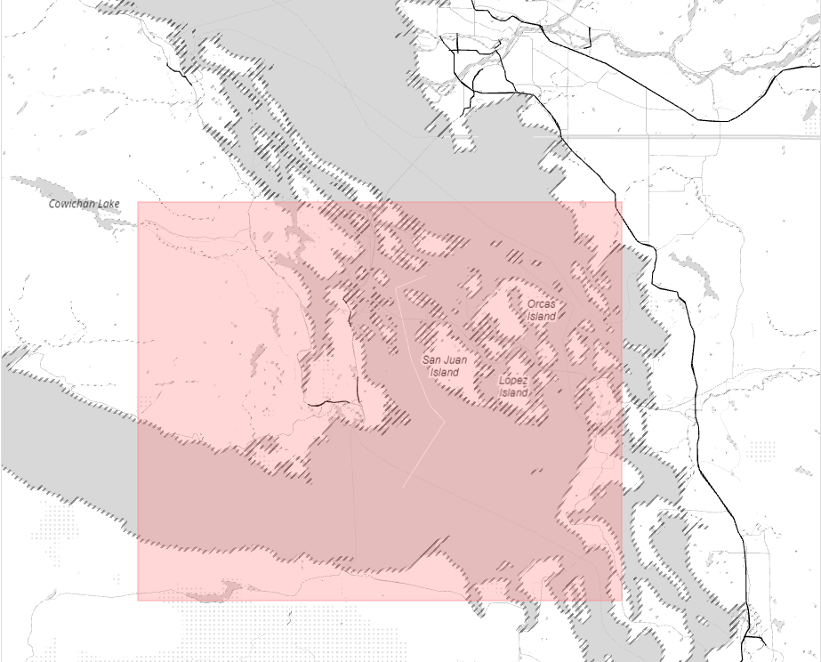

**Project Description:**

According to their website, Opens Street Maps is ‘a free, editable map of the whole world that is being built by volunteers largely from scratch and released with an open-content license.’

All of the data is stored in XML format and submitted by its users. This means that the data is prone to errors, but also relatively easy for users to fix and update.

For this project, I have selected a metro area from Open Street Maps to download in XML format. I then audit the data for consistency, accuracy and validity, making changes to the data where necessary and export the data to a CSV format. Finally, I store the data in a SQL database and use SQL to query the stored data.

**Metro Area:**

For my city, I chose Victoria, Canada. Victoria is located on Vancouver Island, on the southern pacific coast of British Columbia. It is a short ferry ride from my hometown on the Olympic Peninsula of Washington State, a place I went every summer as a child and still visit frequently.

Due to its proximity to Washington State, there is data from both Canada and the US in this extract, which I note in the answer to the rubric questions.

<https://mapzen.com/data/metro-extracts/metro/victoria_canada/>